A web application that facilitates the distribution and return of press products (newspapers and magazines). It is usefull for tracking the logistics chain of a publication. From the moment it is received at the central agency, a publication's quantity is tracked through the entire logistics chain.

There are two user roles: AGENCY and DISTRIBUTOR.

- The AGENCY can:

* Create, update and delete publications. The user clicks on the Publications tab and then clicks: Create new. When a publication is created, the following details are inserted: name, distribution date, return date, issue, quantity.
* Create, update, delete distributors and link them to a user. The user clicks on the Distributors tab and then clicks: Create new. When a distributor is created a name is inserted and a selection of an existing user email from a dropdown menu is made.
* Create, update, delete kiosks and link each kiosk to one distributor. The user clicks on the Kiosks tab and then clicks: Create new. When a kiosk is created a name is inserted and a selection of an existing distributor from a dropdown menu is made.

- The DISTRIBUTOR can:

* Create, update and delete distributions. The user clicks on the Kiosks tab, selects the desired kiosk and clicks on the Distribute button. Then a date must be selected through a calendar. After that, a list of publications that are about to be distributed at this date, is displayed. Then a quantity for each publication is inserted and the submit button is pressed.
* Make an entry of the returns (unsold quantity of a publication that is about to be returned to the distributor and then to the central agency). This can be done in the same screen as before, in the box labeled: Returned quantity

In this view an AGENCY user makes CRUD operations with publications.

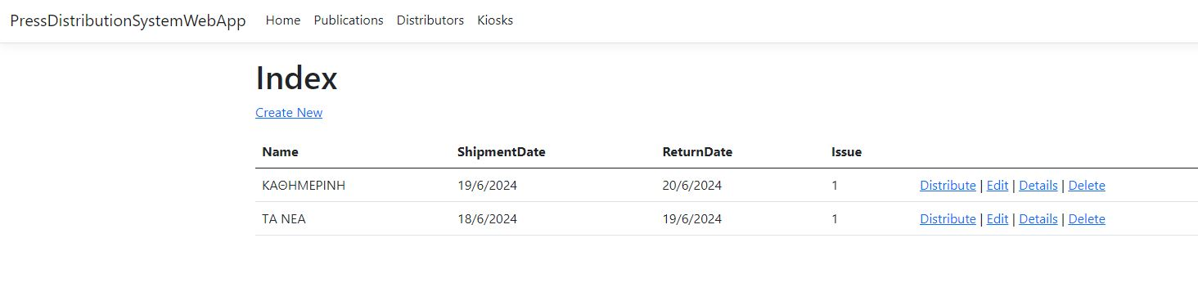

In this view an AGENCY user makes CRUD operations with distributors.

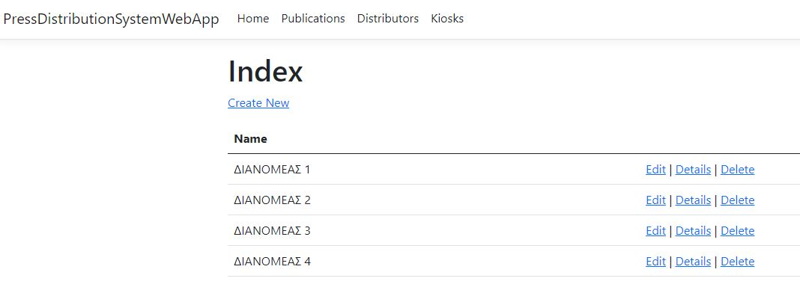

In this view an AGENCY user makes CRUD operations with kiosks

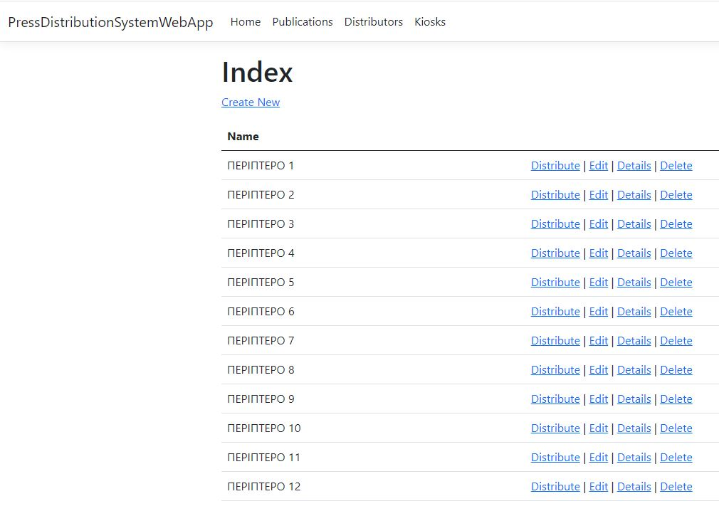

In this view an AGENCY user distributes a publication quantity to the distributors.

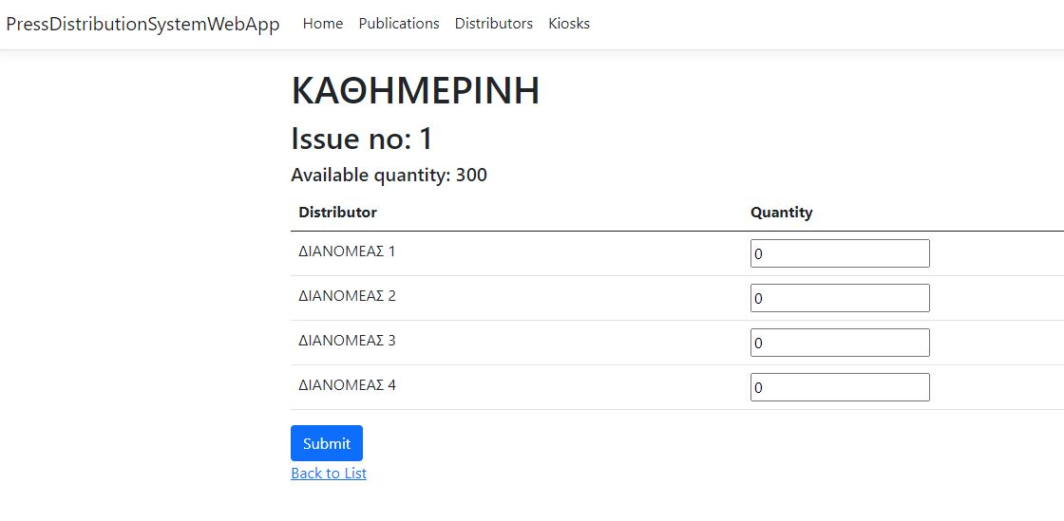

In this view a DISTRIBUTOR user selects the distribution date and then inserts the desired publication quantity to be distributed to a kiosk. We can also record the quantity to be returned in the box that is labeled: Returned quantity.

